Object Detection Tutorial in TensorFlow: Creating accurate Machine Learning Models which are capable of identifying and localizing multiple objects in a single image remained a core challenge in computer vision. But, with recent advancements in Deep Learning, Object Detection applications are easier to develop than ever before. TensorFlow’s Object Detection API is an open source framework built on top of TensorFlow that makes it easy to construct, train and deploy object detection models.
Object detection includes following topics to be understood:-
  - What is Object Detection?
  - Different Applications of Object Detection
  - Object Detection Workflow
  - What is Tensorflow?
  - Real-Time/Live Object Detection

What is Object Detection?
Object Detection is the process of finding real-world object instances like car, bike, TV, flowers, and humans in still images or Videos. It allows for the recognition, localization, and detection of multiple objects within an image which provides us with a much better understanding of an image as a whole. It is commonly used in applications such as image retrieval, security, surveillance, and advanced driver assistance systems (ADAS).
Object Detection can be done via multiple ways:
- Feature-Based Object Detection
- Viola Jones Object Detection
- SVM Classifications with HOG Features
- Deep Learning Object Detection

Applications Of Object Detection

Facial Recognition:
A deep learning facial recognition system called the “DeepFace” has been developed by a group of researchers in the Facebook, which identifies human faces in a digital image very effectively. Google uses its own facial recognition system in Google Photos, which automatically segregates all the photos based on the person in the image. There are various components involved in Facial Recognition like the eyes, nose,Mouth and eyes

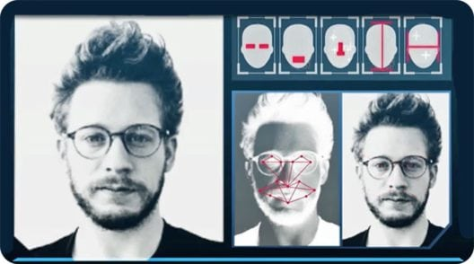

People Counting:

Object detection can be also used for people counting, it is used for analyzing store performance or crowd statistics during festivals. These tend to be more difficult as people move out of the frame quickly.It is a very important application, as during crowd gathering this feature can be used for multiple purposes.

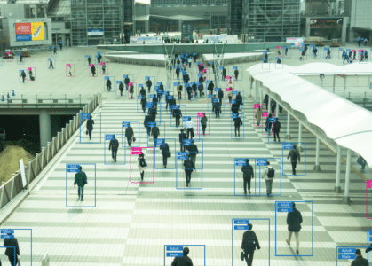

Industrial Quality Check:

Object detection is also used in industrial processes to identify products. Finding a specific object through visual inspection is a basic task that is involved in multiple industrial processes like sorting, inventory management, machining, quality management, packaging etc.



Self Driving Cars:
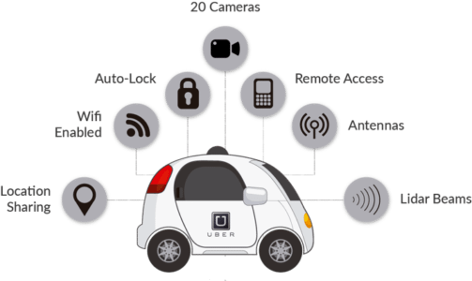
Self-driving cars are the Future, there’s no doubt in that. But the working behind it is very tricky as it combines a variety of techniques to perceive their surroundings, including radar, laser light, GPS, odometry, and computer vision.

Security:

Object Detection plays a very important role in Security. Be it face ID of Apple or the retina scan used in all the sci-fi movies.
It is also used by the government to access the security feed and match it with their existing database to find any criminals or to detect the robbers’ vehicle.
The applications are limitless.

Object Detection Workflow
Every Object Detection Algorithm has a different way of working, but they all work on the same principle.
Feature Extraction: They extract features from the input images at hands and use these features to determine the class of the image. Be it through MatLab, Open CV, Viola Jones or Deep Learning.
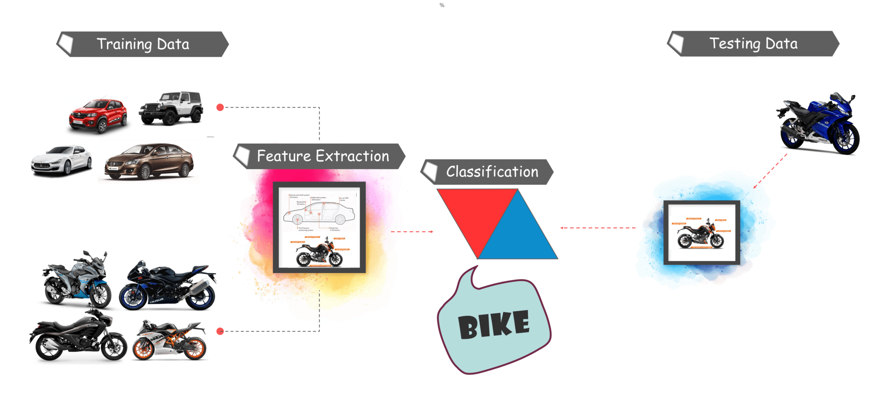
Now that you have understood the basic workflow of Object Detection, let’s move ahead in Object Detection Tutorial and understand what Tensorflow is and what are its components?

What is TensorFlow?
Tensorflow is Google’s Open Source Machine Learning Framework for dataflow programming across a range of tasks. Nodes in the graph represent mathematical operations, while the graph edges represent the multi-dimensional data arrays (tensors) communicated between them.
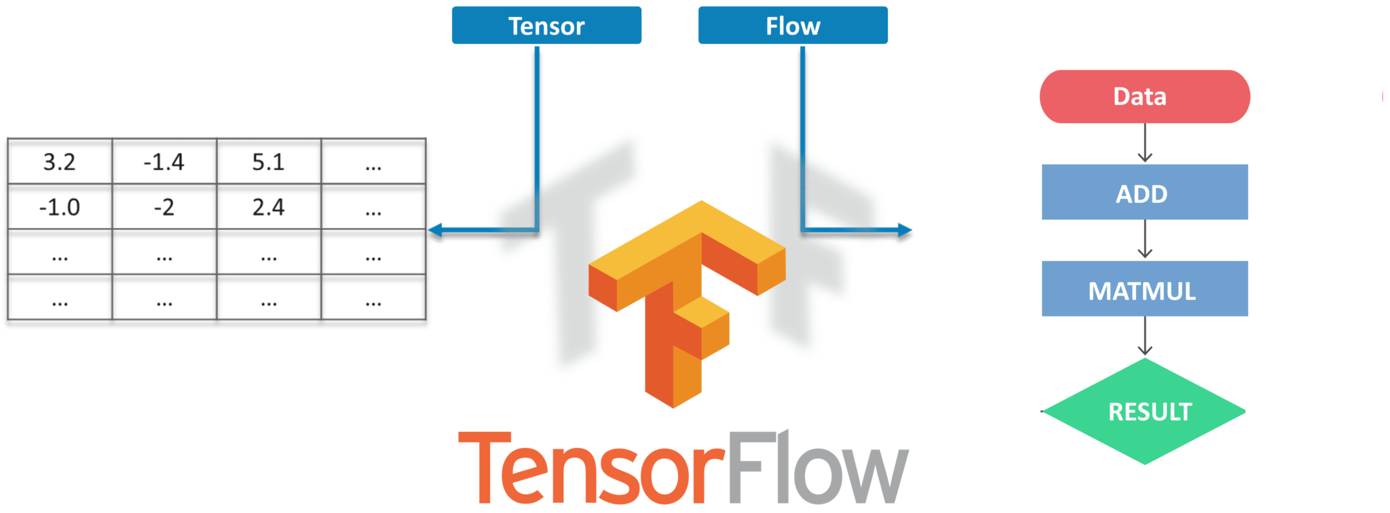
Tensors are just multidimensional arrays, an extension of 2-dimensional tables to data with a higher dimension. There are many features of Tensorflow which makes it appropriate for Deep Learning

THE CODE:
- First of all, we need to import all the libraries
import numpy as np
import os
import six.moves.urllib as urllib
import sys
import tarfile
import tensorflow as tf
import zipfile
import cv2
Cap = cv2.VideoCapture(0)

from object_detection.utils import ops as utils_ops

from utils import label_map_util
from utils import visualization_utils as vis_util

Next, we will download the model which is trained on the COCO dataset. COCO stands for Common Objects in Context, this dataset contains around 330K labeled images. Now the model selection is important as you need to make an important tradeoff between Speed and Accuracy. Depending upon your requirement and the system memory, the correct model must be selected.
Inside “models>research>object_detection>g3doc>detection_model_zoo” contains all the models with different speed and accuracy(mAP).
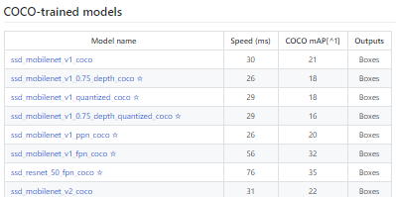

- Next, we provide the required model and the frozen inference graph generated by Tensorflow to use.
MODEL_NAME = 'ssd_mobilenet_v1_coco_2017_11_17'
MODEL_FILE = MODEL_NAME + '.tar.gz'
DOWNLOAD_BASE = '<a href="http://download.tensorflow.org/models/object_detection/">http://download.tensorflow.org/models/object_detection/</a>'

PATH_TO_CKPT = MODEL_NAME + '/frozen_inference_graph.pb'

PATH_TO_LABELS = os.path.join('data', 'mscoco_label_map.pbtxt')

NUM_CLASSES = 90

- This code will download that model from the internet and extract the frozen inference graph of that model.
opener = urllib.request.URLopener()
opener.retrieve(DOWNLOAD_BASE + MODEL_FILE, MODEL_FILE)
tar_file = tarfile.open(MODEL_FILE)
for file in tar_file.getmembers():
file_name = os.path.basename(file.name)
if 'frozen_inference_graph.pb' in file_name:
tar_file.extract(file, os.getcwd())

detection_graph = tf.Graph()
with detection_graph.as_default():
od_graph_def = tf.GraphDef()
with tf.gfile.GFile(PATH_TO_CKPT, 'rb') as fid:
serialized_graph = fid.read()
od_graph_def.ParseFromString(serialized_graph)
tf.import_graph_def(od_graph_def, name='')

- Next, we are going to load all the labels
label_map = label_map_util.load_labelmap(PATH_TO_LABELS)
categories = label_map_util.convert_label_map_to_categories(label_map, max_num_classes=NUM_CLASSES, use_display_name=True)
category_index = label_map_util.create_category_index(categories)
- Now we will convert the images data into a numPy array for processing.
def load_image_into_numpy_array(image):
(im_width, im_height) = image.size
return np.array(image.getdata()).reshape(
(im_height, im_width, 3)).astype(np.uint8)

- The path to the images for the testing purpose is defined here. Here we have a naming convention “image[i]” for i in (1 to n+1), n being the number of images provided.
PATH_TO_TEST_IMAGES_DIR = 'test_images'
TEST_IMAGE_PATHS = [ os.path.join(PATH_TO_TEST_IMAGES_DIR, 'image{}.jpg'.format(i)) for i in range(1, 8) ]

- This code runs the inference for a single image, where it detects the objects, make boxes and provide the class and the class score of that particular object.
def run_inference_for_single_image(image, graph):
with graph.as_default():
with tf.Session() as sess:
# Get handles to input and output tensors
ops = tf.get_default_graph().get_operations()
all_tensor_names = {output.name for op in ops for output in op.outputs}
tensor_dict = {}
for key in [
'num_detections', 'detection_boxes', 'detection_scores',
'detection_classes', 'detection_masks'
]:
tensor_name = key + ':0'
if tensor_name in all_tensor_names:
tensor_dict[key] = tf.get_default_graph().get_tensor_by_name(
tensor_name)
if 'detection_masks' in tensor_dict:
# The following processing is only for single image
detection_boxes = tf.squeeze(tensor_dict['detection_boxes'], [0])
detection_masks = tf.squeeze(tensor_dict['detection_masks'], [0])
# Reframe is required to translate mask from box coordinates to image coordinates and fit the image size.
real_num_detection = tf.cast(tensor_dict['num_detections'][0], tf.int32)
detection_boxes = tf.slice(detection_boxes, [0, 0], [real_num_detection, -1])
detection_masks = tf.slice(detection_masks, [0, 0, 0], [real_num_detection, -1, -1])
detection_masks_reframed = utils_ops.reframe_box_masks_to_image_masks(
detection_masks, detection_boxes, image.shape[0], image.shape[1])
detection_masks_reframed = tf.cast(
tf.greater(detection_masks_reframed, 0.5), tf.uint8)
# Follow the convention by adding back the batch dimension
tensor_dict['detection_masks'] = tf.expand_dims(
detection_masks_reframed, 0)
image_tensor = tf.get_default_graph().get_tensor_by_name('image_tensor:0')

# Run inference
output_dict = sess.run(tensor_dict,
feed_dict={image_tensor: np.expand_dims(image, 0)})

# all outputs are float32 numpy arrays, so convert types as appropriate
output_dict['num_detections'] = int(output_dict['num_detections'][0])
output_dict['detection_classes'] = output_dict[
'detection_classes'][0].astype(np.uint8)
output_dict['detection_boxes'] = output_dict['detection_boxes'][0]
output_dict['detection_scores'] = output_dict['detection_scores'][0]
if 'detection_masks' in output_dict:
output_dict['detection_masks'] = output_dict['detection_masks'][0]
return output_dict

- Next, we don’t need to load the images from the directory and convert it to numPy array as OpenCV will take care of that for us
- This code will use OpenCV that will, in turn, use the camera object initialized earlier to open a new window named “Object_Detection” of the size “800×600”. It will wait for 25 milliseconds for the camera to show images otherwise, it will close the window.
while True:
ret, image_np = cap.read()

# Expand dimensions since the model expects images to have shape: [1, None, None, 3]
image_np_expanded = np.expand_dims(image_np, axis=0)
# Actual detection.
output_dict = run_inference_for_single_image(image_np, detection_graph)
# Visualization of the results of a detection.
vis_util.visualize_boxes_and_labels_on_image_array(
image_np,
output_dict['detection_boxes'],
output_dict['detection_classes'],
output_dict['detection_scores'],
category_index,
instance_masks=output_dict.get('detection_masks'),
use_normalized_coordinates=True,
line_thickness=8)
cv2.imshow('object detection', cv2.resize(image_np, (800,600)))
if cv2.waitKey(25) & 0xFF == ord('q'):
cv2.destroyAllWindows()
break

